Q: Why does the same truck collecting my garbage also collect my recycling and yard waste?
A: The contractors for the District of Summerland use a split truck. This is one vehicle with two compartments that the driver can select with each collection. This allows for one truck to collect two different materials each week. This type of equipment allows for the most efficient collection possible while keeping the materials separate.
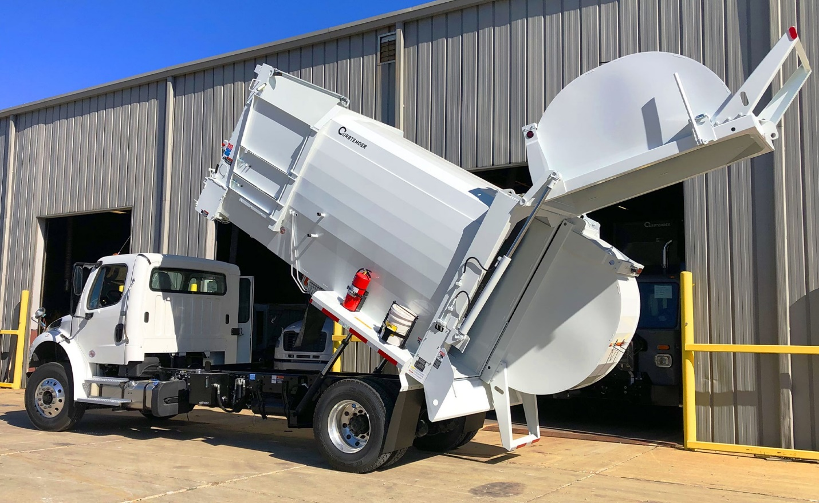
Example of split truck with two sides
Q: How can I change my cart sizes at my home?
A: Click here for information on Cart Change Outs.
Q: How do I report a missed collection?
A: Click here for information on Reporting a Missed Collection
Q: How are materials collected by the District of Summerland at multi-family units like apartments?
A: Summerland presently collects recycling from multi-family units. For more information click Multi-Family Collection.
Q: When will the District of Summerland start collecting food waste?
A: The District is considering options for collecting food waste in 2023 or 2024. Check the District webpage as information becomes available.
Q: Can I opt out of the program?
A: No. All residential properties must participate in the Curbside Collection program.
Q: What do I do with the rest of my items if my carts are full?
A: You can upsize your cart(s), purchase tag-a-bags for extra garbage or yard waste ($2.50 each), and bring extra material to the landfill depot (no charge for recycling or up to 500kg of yard waste). Also be sure to break down boxes and crush milk jugs to maximize space in the carts. Residents are also encouraged to compost their yard waste, leave grass clippings on the lawn, and/or seek out gardening clubs who may want their leaves.
Q: I am a senior (or I am disabled) and am concerned about my ability to maneuver the carts to the curb, is there help?
A: Options for these cases will be discussed on a case-by-case basis. Please contact worksandutilities@summerland.ca or 250.494.0431 so we can help find the best solution for your individual circumstance.
Q: I have a long driveway and feel it is unrealistic for me to wheel the carts up and down to the road. What should I do?
A: You may choose to leave the carts at the base of your driveway (on your property) during the week, and simply move them onto the street on collection day. Many residents in other rural communities with carts choose this option. Essentially you will do the same thing as when you used bags, except when you bring your materials to the curb, you put them into the carts rather than leaving the bags on the curb. The only exception is recycling must be placed loose into the cart, as such, most residents continue to use bags (or a bin or box or mesh bag) but rather than tying them off and placing them in the cart, they simply dump the materials into the cart and reuse the bag.

