Administration Department
13211 Henry Ave. Box 159
Summerland, BC V0H 1Z0
Phone 250 494-6451 Fax 250 494-1415
www.summerland.ca

___

Media Release
For Immediate Release: Oct. 7, 2016
Winning Design Logo Chosen for Summerland Skate-Shirt Design Contest
The District of Summerland and the Summerland Skatepark Committee have chosen the winning design for the Skate-Shirt Design Contest. The contest ran for the month of September. The winning design was submitted by Erin Toews.
Erin Toews, Summerland. “I am so excited to win this contest. Our whole family will be sporting the t-shirts and hats and hopefully so will all our friends. Between myself and my two boys, we had about 10 design submissions. They really wanted this new skateboard… they are going to be thrilled!”
The newly designed Summerland Skatepark t-shirts will be launched for Summerland’s Festival of Lights on November 25th for $20 each. Proceeds will go to the fundraising efforts of the Summerland Skatepark. Jon Alexander, owner of Interior Ink Works in Summerland, generously donated $1,000 worth of t-shirts for the fundraiser. “We’re very happy to be able to support outdoor activities for children and young adults, local and visiting alike. It’s great that projects like this can go ahead to further the sense of community in Summerland and the Okanagan.”
The winning prize is a free skateboard from Freeride Boardshop in Penticton. “We were very excited help out with this fundraiser. We know how a skate park can make a safe area for kids to learn new skills and meet new friends. It is also exciting to see a great town like Summerland put money towards the youth” shares manager Brock Warr.
The total cost of the new Skatepark project is $594,200. The Penny Lane Society has led the way with a donation of $135,000.00. The District of Summerland is awaiting the news of their $300,000 Canada 150 grant application. “We are thrilled so far with the support from the community, businesses and school board. The new Skatepark will be a central feature for Summerland, attracting new visitors to the downtown core and enhancing the attractiveness of our community” states Mayor Peter Waterman.
The District of Summerland has made it easy to contribute to the fundraising efforts by having online donations available at www.summerland.ca/parks-recreation/skatepark. Tax receipts will be issued. For further inquiries contact skatepark@summerland.ca.
Erick Thompson, Chairperson Summerland Skatepark "We have a great new logo and a dedicated fundraising committee. Together, with the support of local businesses, groups and individuals, we're hoping to break ground on a new skatepark for Summerland in 2017. Every donation helps."

----- 30 ----

For more information please contact:
Linda Tynan, Chief Administration Officer, District of Summerland 250-404-4043
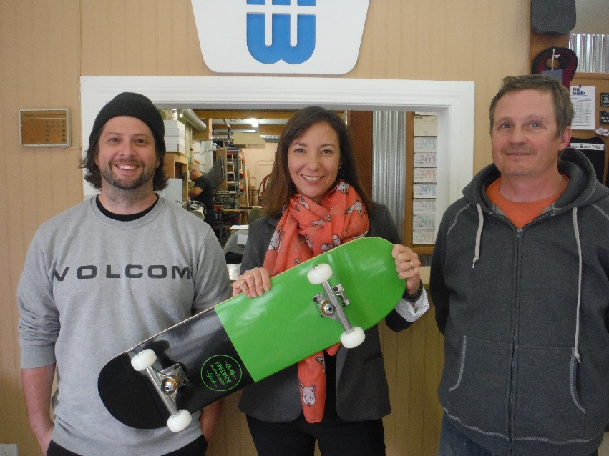
Joanne Malar, Summerland Recreation, jmalar@summerland.ca 250-494-0447

